1. 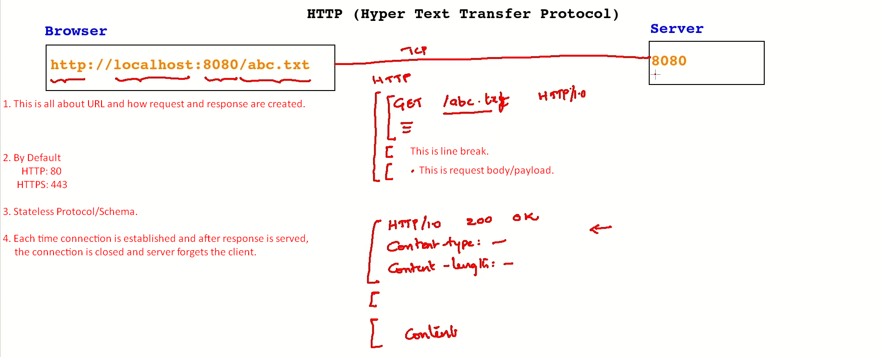
2. Let’s see how request and response happens over the wire through an example.
3. Lecture Not Complete